PROCESS CHART

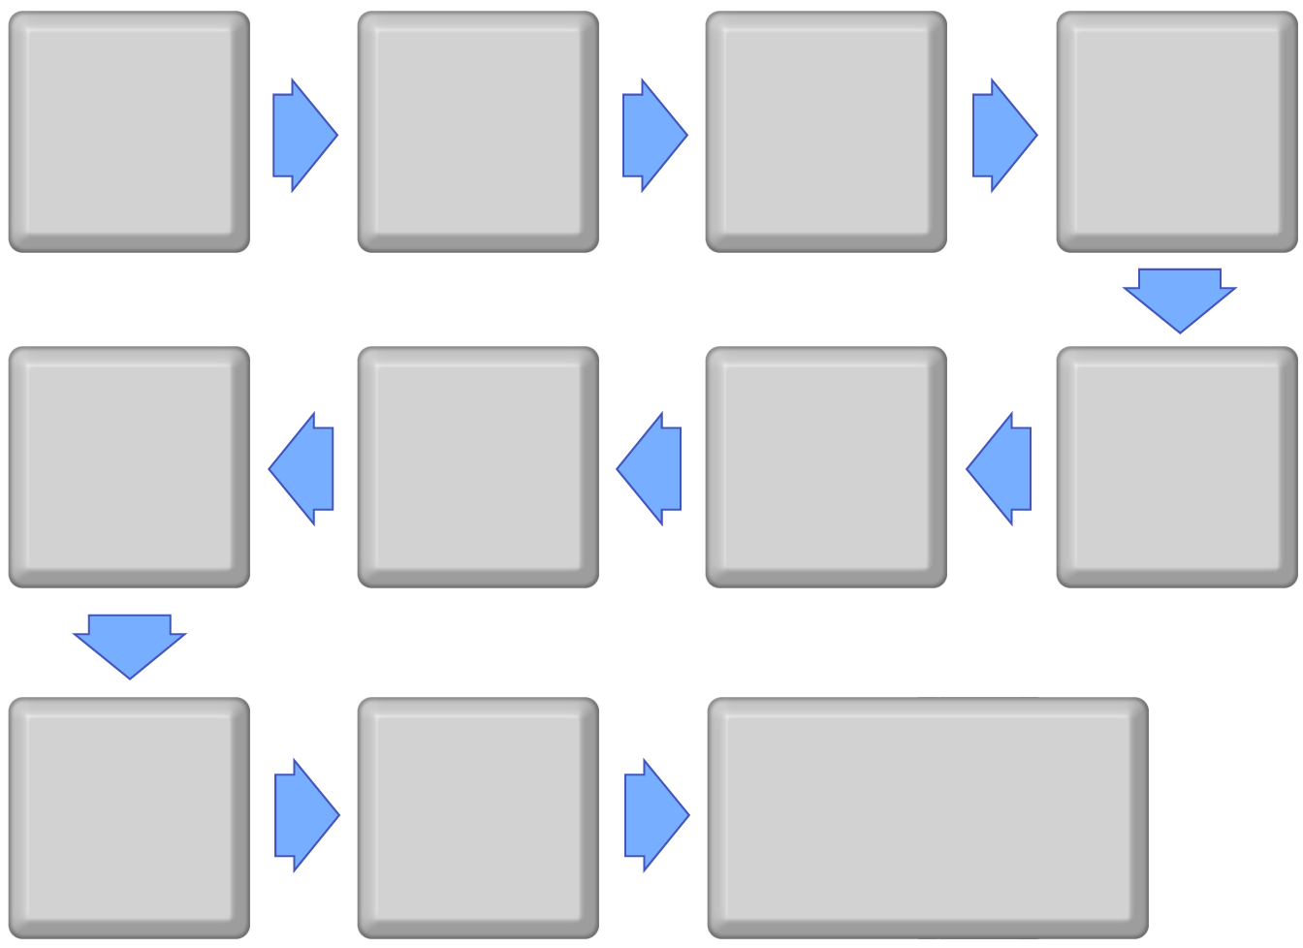
Text here
Text here
Text here
Text here
Text here
Text here
Text here
Text here
Text here
Text here
Text here

