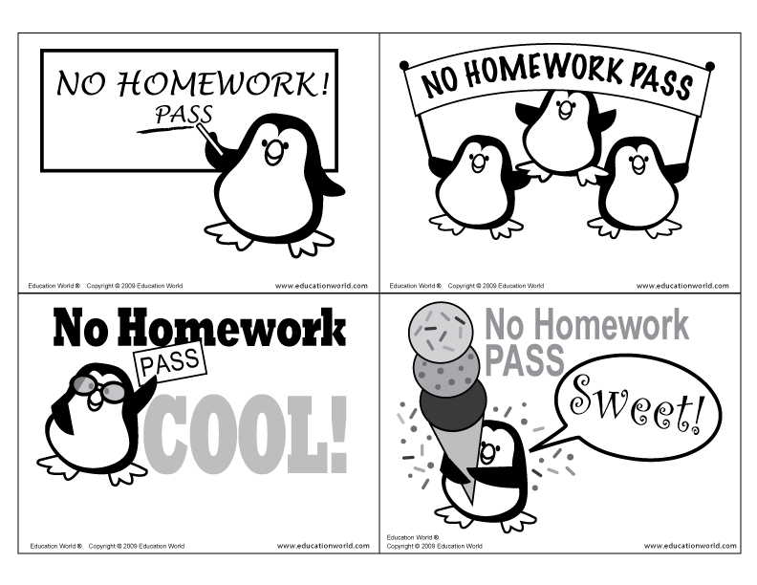
For: ______________________

__________________________

Date: _____________________
For: __________________________

Date: _________________________
For: ___________________________ Date: ____________________ ___________________
For: ___________________________ Date: ____________________ ___________________

