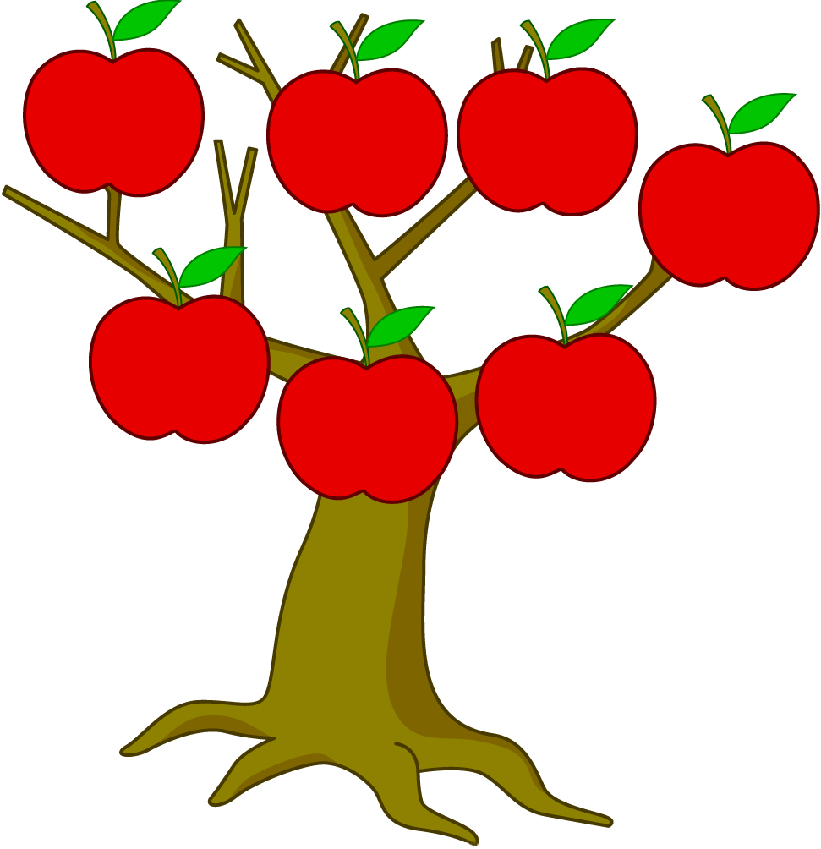
MY GRANDFATHER

_______________
MY GRANDMOTHER

_______________
MY GRANDMOTHER

_______________
MY GRANDFATHER

_______________
MY FATHER

_______________
ME

_______________
MY MOTHER

_______________

