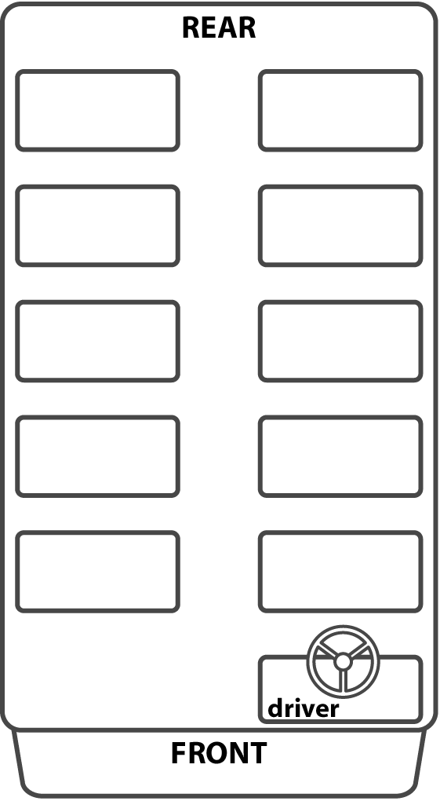
Type here
Type here
Type here
Type here
Type here
Type here
Type here
Type here
Type here
Type here

School Bus Seating Chart

ROUTE: ________________________

