A GOOD WEEK AT CAMP

STUDENTS
TEACHERS
ACTIVITIES

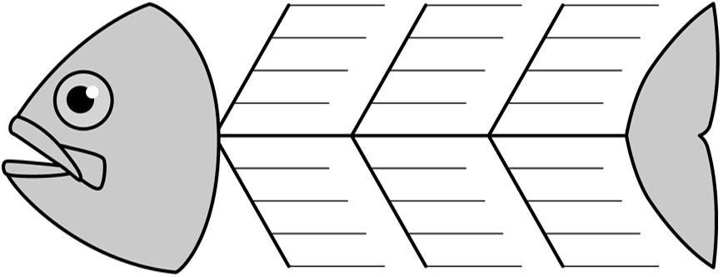
CAMP FACILITIES
OUTDOORS CONDITIONS
OTHER
A GOOD WEEK AT CAMP
(effect)
CAUSE

