TOPIC/TITLE

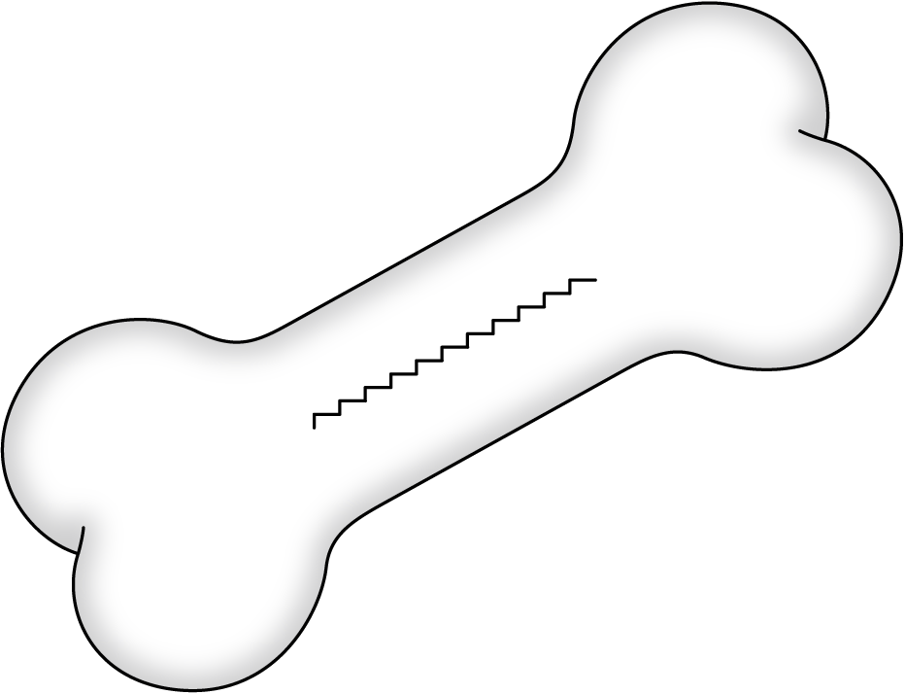
+
DRIVING FORCES
-
RESTRAINING FORCES

Past:
Future:
Action
Steps:

