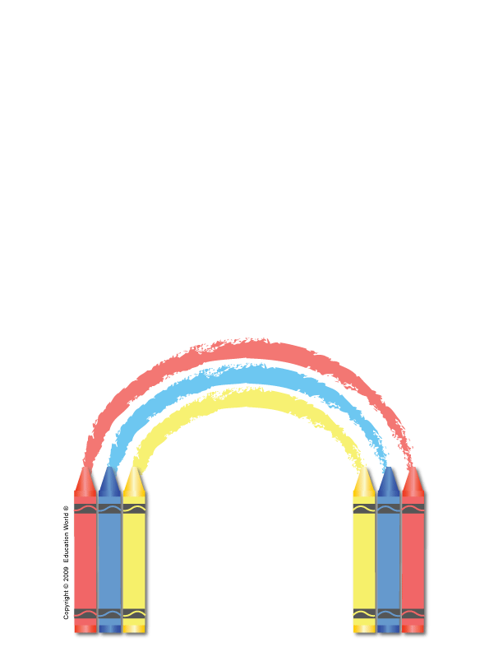
Student's Name

It's time
to say good-bye,
Our year has come to an end.
I've made more cherished memories
And many more new friends.
I've watched you learn and grow
And change from day to day.
I hope that all the things we've done
Have helped in some small way.
So it's with happy memories
I send you out the door.
With great hope and expectations
For what next year holds in store.

