2004 – 2005 School Year Calendar

Insert school/district name here.
September
Insert important dates/events here.
October
Insert important dates/events here.
November
Insert important dates/events here.
December
Insert important dates/events here.
January
Insert important dates/events here.
February
Insert important dates/events here.
March
Insert important dates/events here.
April
Insert important dates/events here.
May
Insert important dates/events here.
June
Insert important dates/events here.
July
Insert important dates/events here.
August
Insert important dates/events here.
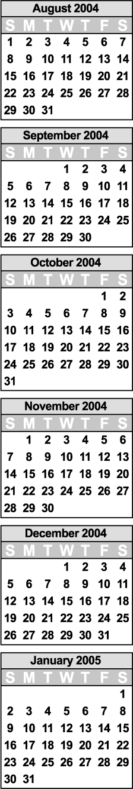
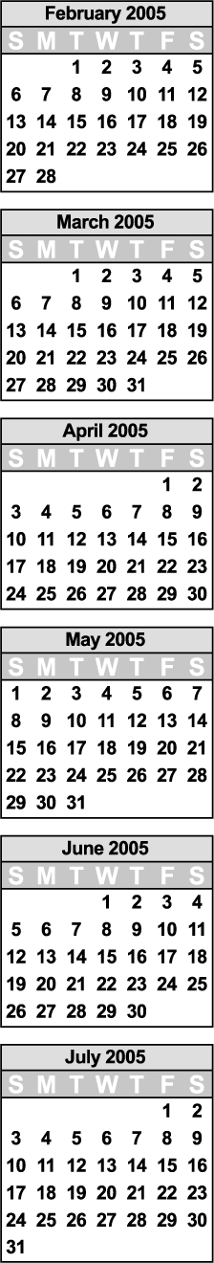

© 2004 by Education World®. Education World grants users permission to reproduce this work sheet for educational purposes only.

