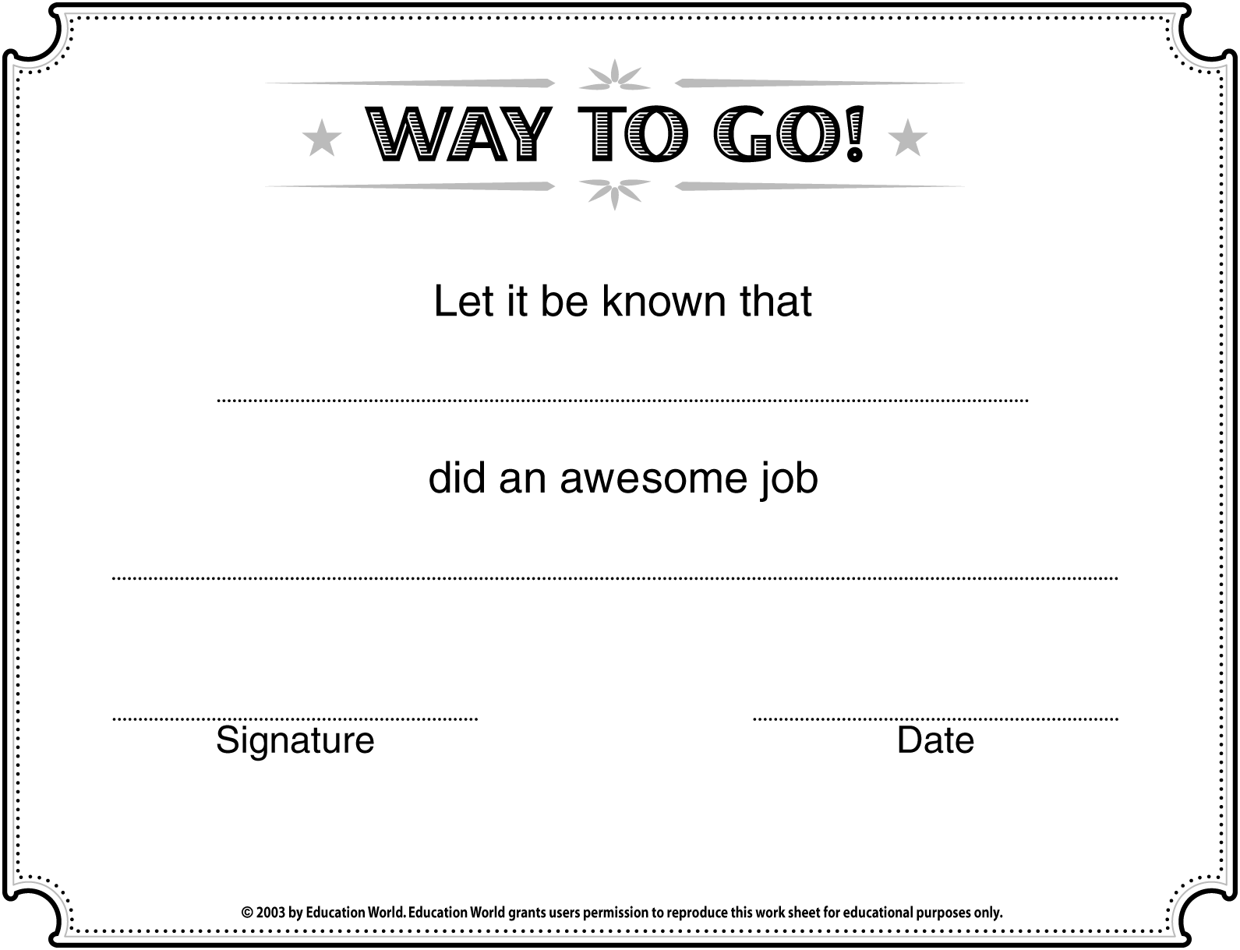
Insert NAME here
Insert APPROPRIATE COMMENTS here

Insert SCHOOL/CLASS NAME here


