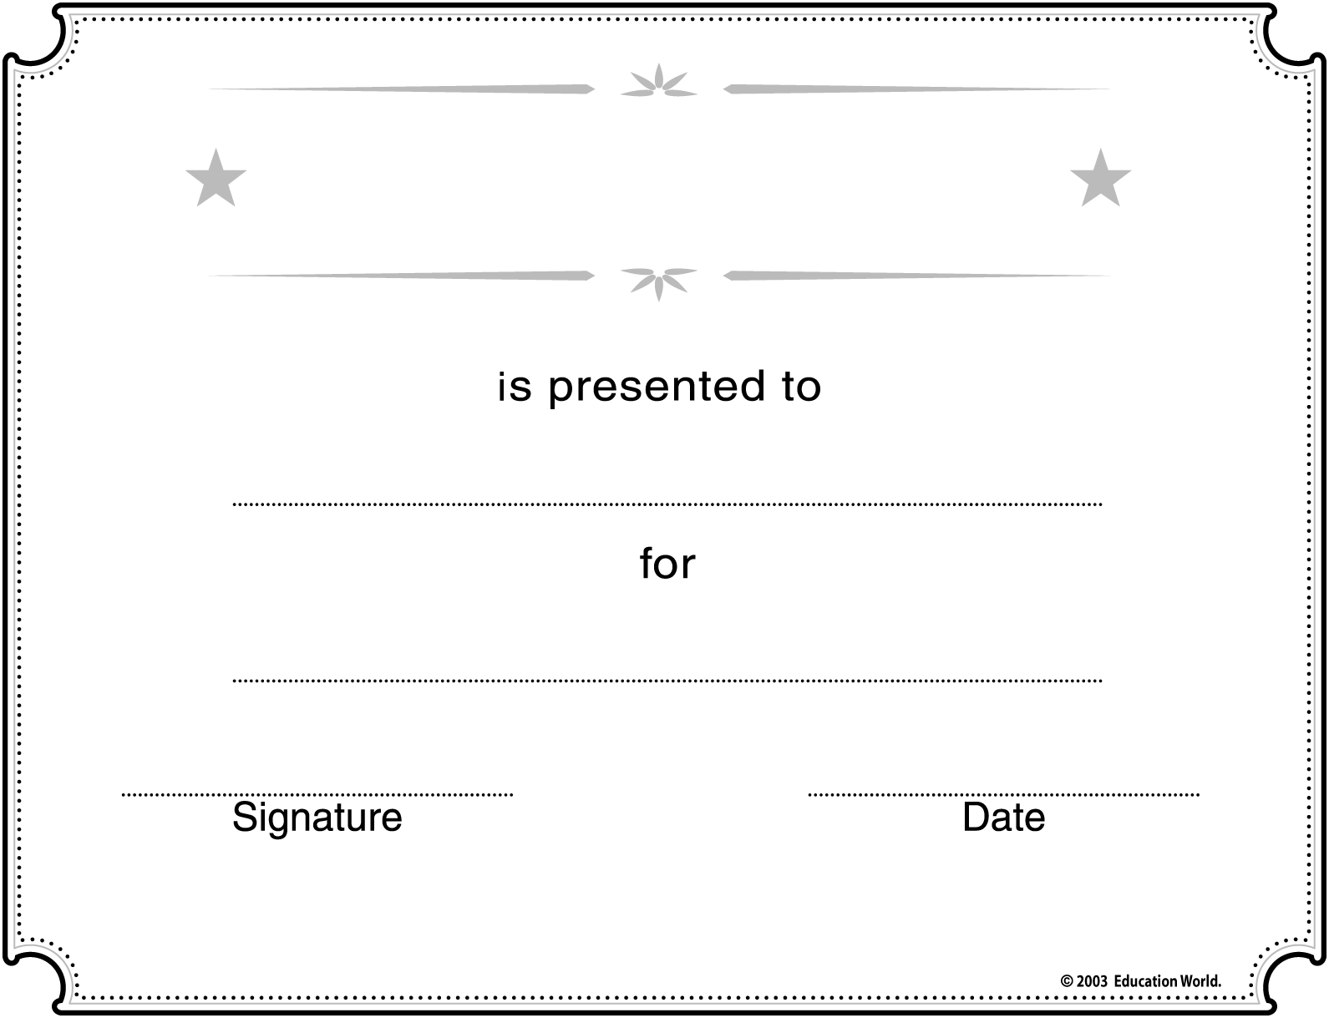
Insert STUDENT’S NAME here
Insert APPROPRIATE COMMENTS here

Insert SCHOOL/CLASS NAME here

Insert TITLE here

