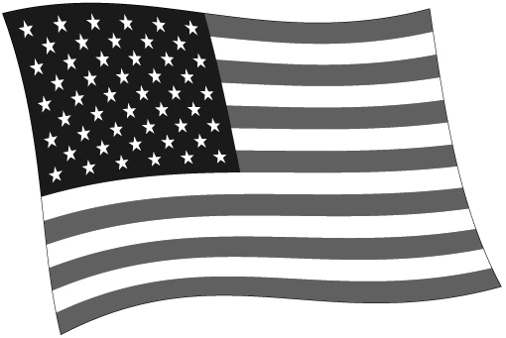
LEVELS OF GOVERNMENT
© 2004 by Education World®. Education World grants users permission to reproduce this work sheet for educational purposes only.
National:

Makes laws for the entire country. Handles relations with other countries. Resolves disputes between states.
Responsibilities include:

- U.S. military - Passports and visas
- Coining money - International trade
- Interstate highways - Federal income tax
- Social Security - Interstate commerce
State:

Makes laws for one state. Resolves disputes between citizens within the state.
Responsibilities include:

- State Police - Automobile registration and driver’s licenses
- Property - Intrastate commerce
- State highways - State sales tax
- Welfare - Education
Local: County, Town and Township, Municipality, Special District, School District

Makes laws for a small area within a state. Enforces local laws and ordinances.
Responsibilities include:

- Police and Fire - Voter registration
- Planning and zoning - Recreation
- Local roads - Property tax
- Trash collection - School districts

