
CAMPAIGN TIMELINE
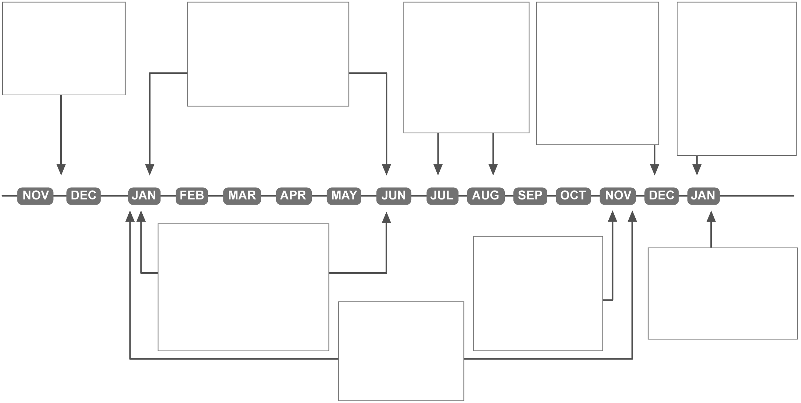
Candidates declare their intention to run for the office of president.
States hold primaries and caucuses to choose delegates for national party conventions.
Delegates at national party conventions choose Republican and Democratic nominees for president and vice president.
On the first Monday after the second Wednesday in December, the electors from all 50 states vote for president and vice president.
On January 6, the President of the Senate counts the electoral votes. To win the election, a candidate must receive one half of the total votes plus one vote.
Democratic and Republican candidates campaign for their party's nomination. Independent candidates circulate petitions to qualify for a certificate of nomination.
On the Tuesday after the first Monday in November, voters choose presidential electors in a general election.
Independent candidates campaign for public support.
On January 20, the new president and vice president are inaugurated.
© 2004 by Education World®. Education World grants users permission to reproduce this work sheet for educational purposes only.

