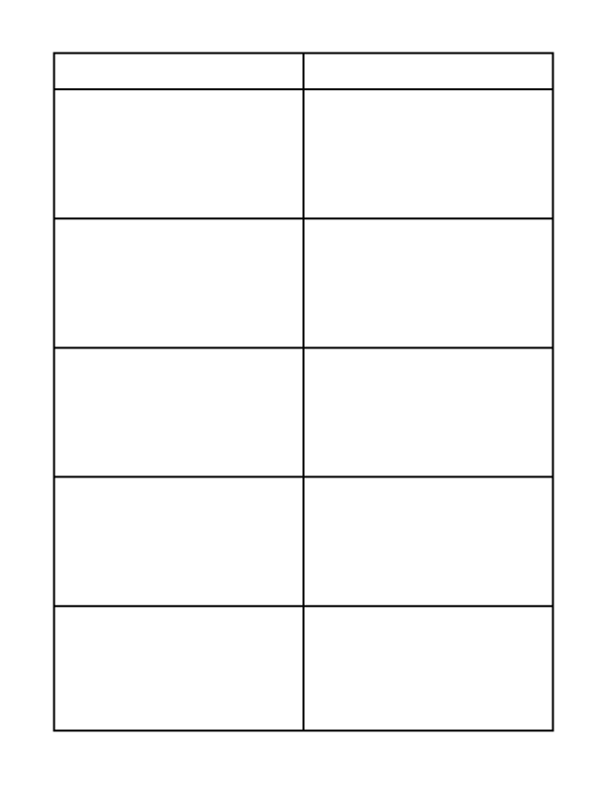

Place Disadvantages, Cons, or Opinions Here

Place Advantages, Pros, or Facts Here
T-Chart Education World ® Copyright © 2009 Education World www.educationworld.com
Text here

Text here

Text here

Text here

Text here
Text here

Text here

Text here

Text here

Text here

