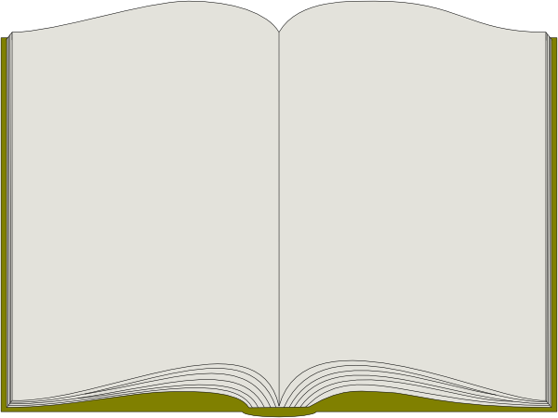

© EducationWorld 2013

Click here to enter text.

has made outstanding   
progress in reading!

Recognized this date:

Click here to enter text.

_____________________

*Signed*

Remarkable Reader