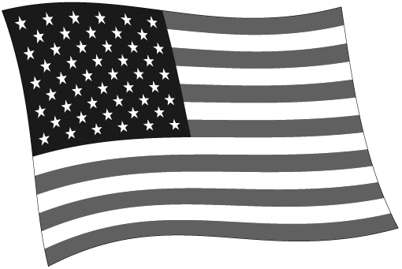
PRESIDENTS

President | Party | Term | Vice President | Significant Accomplishment
George Washington |  | 1789-1797 | John Adams
John Adams | Federalist | 1797-1801 | Thomas Jefferson
Thomas Jefferson | Democratic-Republican | 1801-1805 | Aaron Burr
 |  | 1805-1809 | George Clinton
James Madison | Democratic-Republican | 1809-1812 | George Clinton
 |  | 1812-1813 | none
 |  | 1813-1814 | Elbridge Gerry
 |  | 1814-1817 | none
James Monroe | Democratic-Republican | 1817-1825 | Daniel Tompkins
John Quincy Adams | Democratic-Republican | 1825-1829 | John Calhoun
Andrew Jackson | Democrat | 1829-1832 | John Calhoun
 |  | 1832-1833 | none
 |  | 1833-1837 | Martin Van Buren
Martin Van Buren | Whig | 1837-1841 | Richard Johnson
William Henry Harrison | Whig | 1841 | John Tyler
John Tyler | Whig | 1841-1845 | none
James K. Polk | Democrat | 1845-1849 | George Dallas
Zachary Taylor | Whig | 1849-1850 | Millard Fillmore
Millard Fillmore | Whig | 1850-1853 | none
Franklin Pierce | Democrat | 1853 | William King
 |  | 1853-1857 | none
James Buchanan | Democrat | 1857-1861 | John Breckenridge
Abraham Lincoln | Republican | 1861-1865 | Hannibal Hamlin
 |  | 1865 | Andrew Johnson
Andrew Johnson | Democrat/  National Union | 1865-1869 | none
Ulysses S. Grant | Republican | 1869-1873 | Schuyler Colfax
 |  | 1873-1875 | Henry Wilson
 |  | 1875-1877 | none
Rutherford B. Hayes | Republican | 1877-1881 | William Wheeler
James A. Garfield | Republican | 1881 | Chester Arthur
Chester A. Arthur | Republican | 1881-1885 | none
Grover Cleveland | Democrat | 1885 | Thomas Hendricks
 |  | 1885-1889 | none
Benjamin Harrison | Republican | 1889-1893 | Levi Morton
Grover Cleveland | Democrat | 1893-1897 | Adlai Stevenson
William McKinley | Republican | 1897-1901 | Garret Hobart
 |  | 1901 | Theodore Roosevelt
Theodore Roosevelt | Republican | 1901-1905 | none
 |  | 1905-1909 | Charles Fairbanks
William Howard Taft | Republican | 1909-1912 | James Sherman
 |  | 1912-1913 | none
Woodrow Wilson | Democrat | 1913-1921 | Thomas Marshall
Warren G. Harding | Republican | 1921-1923 | Calvin Coolidge
Calvin Coolidge | Republican | 1923-1925 | none
 |  | 1925-1929 | Charles Dawes
Herbert Hoover | Republican | 1929-1933 | Charles Curtis
Franklin D. Roosevelt | Democrat | 1933-1941 | John Nance Garner
 |  | 1941-1945 | Henry Wallace
 |  | 1945 | Harry S. Truman
Harry S. Truman | Democrat | 1945-1949 | none
 |  | 1949-1953 | Alben Barkley
Dwight D. Eisenhower | Republican | 1953-1961 | Richard Nixon
John F. Kennedy | Democrat | 1961-1963 | Lyndon B. Johnson
Lyndon B. Johnson | Democrat | 1963-1965 | none
 |  | 1965-1969 | Hubert Humphrey
Richard M. Nixon | Republican | 1969-1973 | Spiro Agnew
 |  | 1973 | none
 |  | 1973-1974 | Gerald Ford
Gerald Ford | Republican | 1974 | none
 |  | 1974-1977 | Nelson Rockefeller
Jimmy Carter | Democrat | 1977-1981 | Walter Mondale
Ronald Reagan | Republican | 1981-1989 | George H. Bush
George H. Bush | Republican | 1989-1993 | Dan Quayle
Bill Clinton | Democrat | 1993-2001 | Al Gore
George W. Bush | Republican | 2001-2009 | Dick Cheney
Barack Obama | Democrat | 2009-2016 | Joe Biden

© 2012 by Education World®. Education World grants users permission to reproduce this work sheet for educational purposes only.

