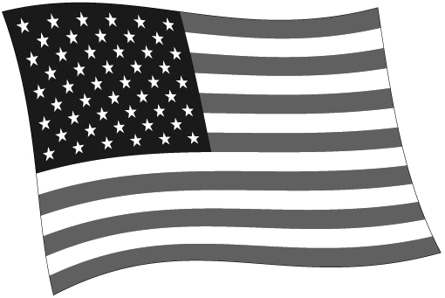
ELECTORAL VOTE TALLY

State | Electoral Votes | Candidate | Candidate | Candidate | Candidate
Alabama | 9
Alaska | 3
Arizona | 11
Arkansas | 6
California | 55
Colorado | 9
Connecticut | 7
Delaware | 3
District of Columbia | 3
Florida | 29
Georgia | 16
Hawaii | 4
Idaho | 4
Illinois | 20
Indiana | 11
Iowa | 6
Kansas | 6
Kentucky | 8
Louisiana | 8
Maine | 4
Maryland | 10
Massachusetts | 11
Michigan | 16
Minnesota | 10
Mississippi | 6
Missouri | 10
Montana | 3
Nebraska | 5
Nevada | 6
New Hampshire | 4
New Jersey | 14
New Mexico | 5
New York | 29
North Carolina | 15
North Dakota | 3
Ohio | 18
Oklahoma | 7
Oregon | 7
Pennsylvania | 20
Rhode Island | 4
South Carolina | 9
South Dakota | 3
Tennessee | 11
Texas | 38
Utah | 6
Vermont | 3
Virginia | 13
Washington | 12
West Virginia | 5
Wisconsin | 10
Wyoming | 3
TOTAL | 538

Total Needed: 270
© 2011 by Education World®. Education World grants users permission to reproduce this work sheet for educational purposes only.

