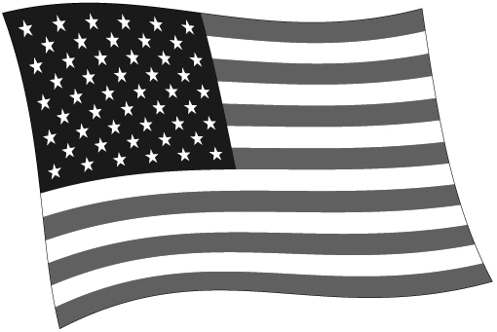
12
7
55
6
11
6
4
3
3
9
5
3
3
5
6
7
38
3
4
10
6
10
6
8
10
20
11
8
9
6
16
29
15
9
13
5
18
11
16
29
20
3
4
4
11
4
7
14
3
10
3
ELECTORAL COLLEGE MAP
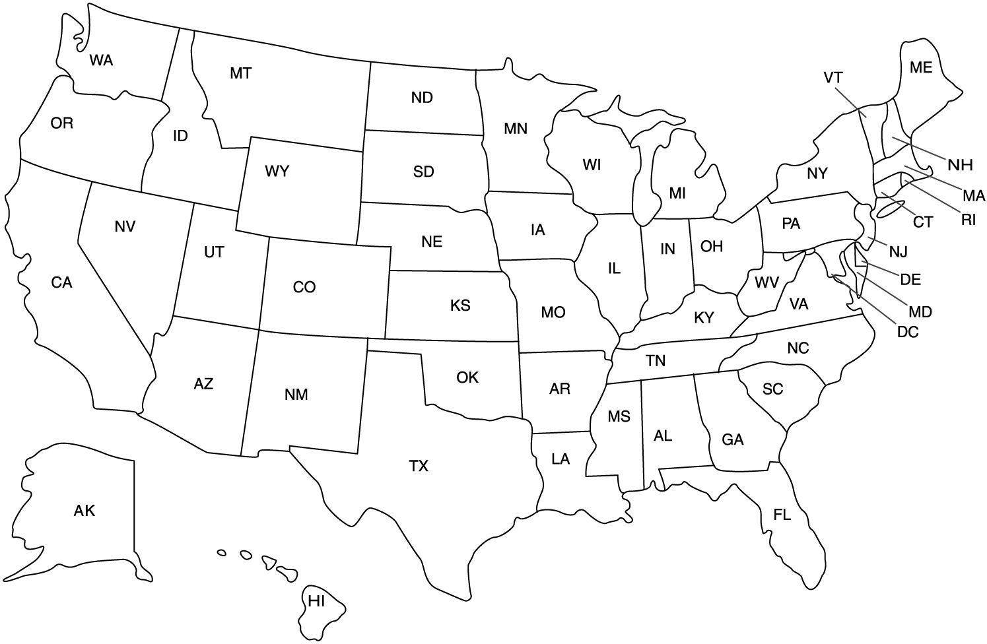
© 2011 by Education World®. Education World grants users permission to reproduce this work sheet for educational purposes only.

