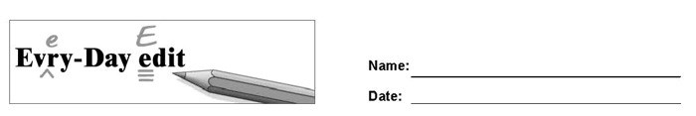

Pumpkins

Can you find and mark the errors in the paragraph below? You might look for errors of capitalization, punctuation, spelling, or grammar.

october is a good time to harvist pumpkins. they can be used for many different purpose. Some are carved into jack-o’-lanterns, while others are baked into deserts and breads. Pupkin seeds can be a special treat when roasted The bigest pumpkin ever recorded waighed over 1,800 pounds. Thats as much as a car!

© 2020 by Education World®. Education World grants users permission to reproduce this work sheet for educational purposes only.

