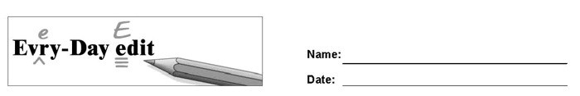

Matt Groening

Can you find and mark the errors in the paragraph below? You might look for errors of capitalization, punctuation, spelling, or grammar.

Matt Groening is a Cartoonist and screenwriter best known four creating the television show The Simpsons. He allso invented the show Futurama. The members of the cartoon Simpsons family was named after Groenings own parents an sisters. Bart was named buy moving around the letters of “brat.” there have been hundreds of episodes of The Simpsons. Groening winned many awards and got his own star on the Hollywood Walk of Fame in 2012

© 2020 by Education World®. Education World grants users permission to reproduce this work sheet for educational purposes only.

