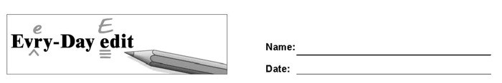

Super Bowl

Can you find and mark the errors in the paragraph below? You might look for errors of capitalization, punctuation, spelling, or grammar.

around the beginning of Febuary each year, the top too American football teams meet for a big game. The game is called the Super bowl. It is the annual championship for the Nashional Football League. The Super Bowl is always held on a Sunday. Many Americans treat Super Bowl Sunday as a holiday On Super Bowl Sunday, America eat more food then on any other holiday, except for Thanksgiving. They go to Super Bowl Parties and cheer for their favorite teams. Thousands of people watch the Super Bowl in the stadium, but millions watch it on TV. In fact, the Super Bowl is one of the most-watch programs on TV every year.

© 2020 by Education World®. Education World grants users permission to reproduce this work sheet for educational purposes only.

