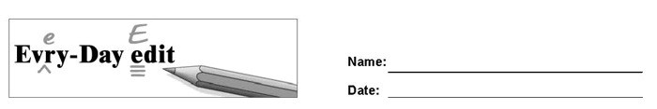

Paul Revere's Ride

Can you find and mark the errors in the paragraph below? You might look for errors of capitalization, punctuation, spelling, or grammar.

Paul revere was born on January 1 1735. He grew up to become a silversmith, but he were best known for his famous ride. On April 18, 1775, Paul Revere is sent to warn Samuel Adams and John Hancock that the British were coming He stop at every house to warn they. Two other men, William Dawes and Samuel Prescott, also rode hoarses, but Paul Revere became famous. All 3 men were arrested by the British but Hancock and Adams were safe.

© 2020 by Education World®. Education World grants users permission to reproduce this work sheet for educational purposes only.

