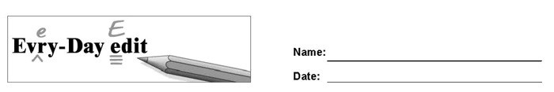

LeBron James

Can you find and mark the errors in the paragraph below? You might look for errors of capitalization, punctuation, spelling, or grammar.

Born on December 30 1984, LeBron James is known as one of the worlds best basketball players. After growing up in akron, Ohio, Lebron spent seven years playing for the Cleveland Cavaliers. He scored alot of points and help his teammates score, too. People in Ohio were disapointed when he leaved to join the Miami Heat. In 2013, LeBron led the Heat to they're second championship Victory in a row. In 2014 he returned to the Cavaliers.

© 2020 by Education World®. Education World grants users permission to reproduce this work sheet for educational purposes only.

