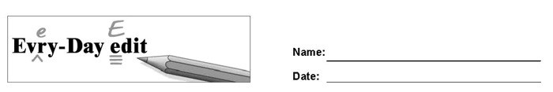

Jackie Robinson

Can you find and mark the errors in the paragraph below? You might look for errors of capitalization, punctuation, spelling, or grammar.

Who was the first player to brake the color barrier in Major League Baseball (MLB). The answer is Jackie Robinson. Robinson played 10 seasons for the Brooklyn dodgers. During his career, he won the Rookie of the Year and Most Valuable Player award. He also appears in six World Series. In addition to being an incredibly gifted ballplayer he is regarded as a important figure in the Civil Rights Movement. Robinson was inducted in the Baseball Hall of Fame in 1962. In 2004, MLB introduced “Jackie Robinson Day,” which celebrates he's life and achievements. On that day, every baseball player, manager and umpire wears Robinsons old jersey number 42.

© 2020 by Education World®. Education World grants users permission to reproduce this work sheet for educational purposes only.

