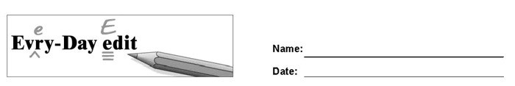

Flag Day

Can you find and mark the errors in the paragraph below? You might look for errors of capitalization, punctuation, spelling, or grammar.

In July we celebrate america’s Independence with the Forth of July, but in June we celebrate another important cymbal of America – the American Flag. On June 14, 1777 the flag of the United States was officially adapted. Woodrow wilson officially named June 14 National Flag Day on 1916. On flag Day, people proudly display the American Flag, also known as the Stars and Strips.

© 2020 by Education World®. Education World grants users permission to reproduce this work sheet for educational purposes only.

------------------------------------------------------------------------------------------------------------

Flag Day

Can you find and mark the errors in the paragraph below? You might look for errors of capitalization, punctuation, spelling, or grammar.

In July we celebrate america’s Independence with the Forth of July, but in June we celebrate another important cymbal of America – the American Flag. On June 14, 1777 the flag of the United States was officially adapted. Woodrow wilson officially named June 14 National Flag Day on 1916. On flag Day, people proudly display the American Flag, also known as the Stars and Strips.

© 2020 by Education World®. Education World grants users permission to reproduce this work sheet for educational purposes only.

