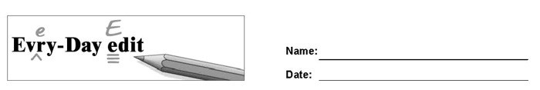

Albert Einstein

Can you find and mark the errors in the paragraph below? You might look for errors of capitalization, punctuation, spelling, or grammar.

Celebrated pyhsicist Albert Einstein was born on March 14, 1879, in Ulm, Germany. Einstein began developing some of his ground breaking theories while working as a clerk in a swiss patent office. In 1905, he had what he considered a “miracle year,” in which he published for influential papers that transformed the world of physics. In one of these papers he introduced the general theory of relativity, which have been regarded as one of the gratest contributions to science. He's defining impact on theoretical physics earned him the Nobel Prize in 1921. In 1933, Einstein immigrated from Nazi Germany to the United States out of concern for he and his wife safety. He became an American citizen in 1940.

© 2020 by Education World®. Education World grants users permission to reproduce this work sheet for educational purposes only.

