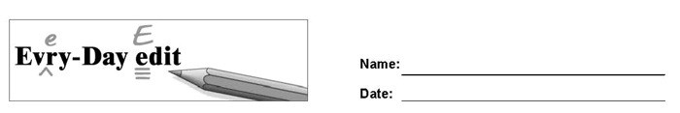

Black Friday

Can you find and mark the errors in the paragraph below? You might look for errors of capitalization, punctuation, spelling, or grammar.

Every November, stores offer special sales in the friday after Thanksgiving. the day is know as Black Friday because when busineses make a lot of monney, they call it “being in the black.” black Friday starts the holiday shoping season and is the time when many people bye gifts for friends an family.

© 2020 by Education World®. Education World grants users permission to reproduce this work sheet for educational purposes only.

