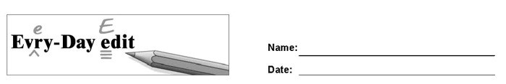

Jim Henson's Muppets

Can you find and mark ten errors in the paragraph? You might look for errors of capitalization, punctuation, spelling, or grammar.

You probably reconize Miss Piggy, big bird, and Oscar the Grouch, but do you know Jim Henson. Henson was the man behind the Muppets. He is born in Mississippi on September 24 1936. Henson created the Muppets in 1956. He one many awards for "Sesame Street" and "The Mupet Show." Did you know that he was also the voice of Kermit the frog and Ernie! Henson died unexpectedly in 1990 at the age of 53.

© 2021 by Education World®. Education World grants users permission to reproduce this work sheet for educational purposes only.
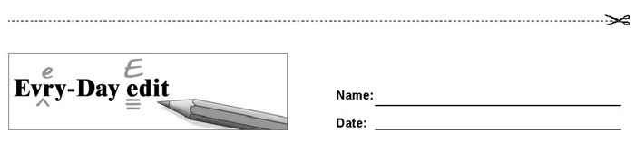
Jim Henson's Muppets

Can you find and mark ten errors in the paragraph? You might look for errors of capitalization, punctuation, spelling, or grammar.

You probably reconize Miss Piggy, big bird, and Oscar the Grouch, but do you know Jim Henson. Henson was the man behind the Muppets. He is born in Mississippi on September 24 1936. Henson created the Muppets in 1956. He one many awards for "Sesame Street" and "The Mupet Show." Did you know that he was also the voice of Kermit the frog and Ernie! Henson died unexpectedly in 1990 at the age of 53.

© 2021 by Education World®. Education World grants users permission to reproduce this work sheet for educational purposes only.

