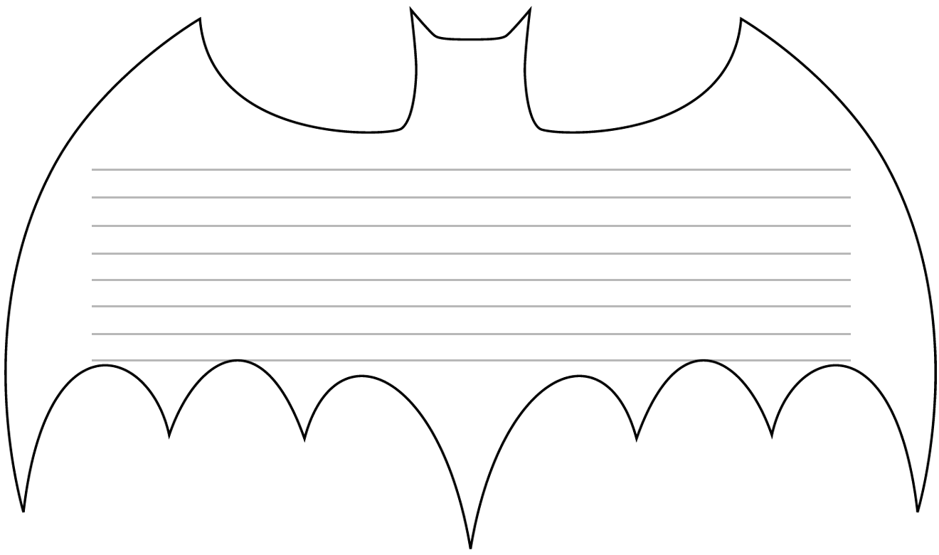

Write here
© 2005 by Education World®. Education World grants users permission to reproduce this work sheet for educational purposes only.

