Record It With Audacity
By Lorrie Jackson

WHY A TECHTORIAL?

What will I learn today?
You will learn how to record, edit, and share sound files.
What hardware and/or software does the techtorial apply to?
The techtorial applies to Audacity, a free sound editor for both PC and Mac, and Lame, an mp3 encoder.
Which National Educational Technology Standards for Teachers does the techtorial address?
The techtorial will help teachers accomplish standard IIa in particular.

The International Society for Technology in Education (ISTE) has developed a set of National Educational Technology Standards for Teachers. Standards or Performance Indicators are included for each techtorial to help teachers and administrators improve technology proficiency. For a complete description of the standards indicated, go to <a href=" http://cnets.iste.org/teachers/t_stands.html" target="_blank">NETS for Teachers</a>.

SOUNDING OFF IN CLASS
Have you ever wanted to:
- record a lecture for an absent student?
- capture an original song, chant, or cheer created by students?
- share a student interview with a famous visitor?
- narrate a book for students with learning difficulties?
- post a school recital online for parents?
All those and many more sound-related activities are available free (or for little cost) in just minutes with Audacity, a free, truly point-and-click, sound-editing program for PC, Mac, and Linux. Students as young as first grade can quickly learn and begin to use Audacity, not only for recording sound, but also for editing what they record.
Next: Installing Audacity.

INSTALL AUDACITY
Audacity is an “open source” program, but don’t let the term scare you! Installing Audacity takes no time at all. Just
- Go to the Audacity Web site.
- Click the green Download button.
- Click another green button (don’t click a copy marked “beta” or “unstable”) to select the current copy of Audacity.
- Choose the .exe file (PC users) third in the list below or the .dmg file (Mac users) at the top of the list.
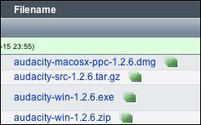
- A prompt might ask if you want to save the file. Click OK or Save.
- Double-click the .exe or .dmg file that appears on your Desktop, it and the program will install in just a minute or two.
You know you have successfully installed Audacity when you see the icon below appear on your Desktop (PC), Start Bar (PC), or Dock (Mac).
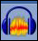
Besides installing Audacity on a classroom computer, you’ll also need a microphone. Most laptops and some desktops now have internal mics, which work fine for basic recording. If yours does not, or if you want better sound or to record large groups of students, you’ll want to pick up a microphone at an electronics or discount retail store. Those can be as cheap as $10 and usually plug in to your computer near where your headphones plug in (the port often is red indicating “record”). Tip: If you can, try to pick up a headphone/microphone combo. Those start around $20. The headphones block out classroom noises that might distract a student as she/he records.
Let’s get started!
Next: Recording sound.

STEP ONE: RECORD SOUND
When you open Audacity, the window/pane below will appear.
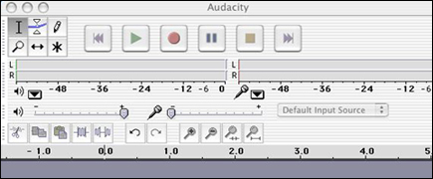
In sound recording software, the color red usually means record and green means play. To record, click the red circle. To stop recording, press the yellow square. To play back your recording, press the green triangle. Easy, huh?
Now, record a test -- hum, bark, sing “Happy Birthday”..anything.
Next: Simultaneous or consecutive recording?

SIMULTANEOUS AND CONSECUTIVE SOUNDS
Notice that when you record, an “audio track” appears.
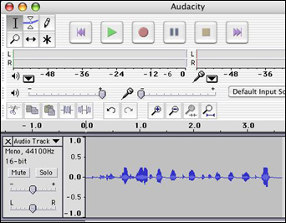
If, while recording, you click the yellow square to stop recording and then begin recording again, you’ll create a new audio track. Both tracks then will play at the same time. That is helpful if you teach music, for example, and want to record one student playing guitar, while another plays drums, and a third plays keyboard, and then play all three tracks simultaneously.
If you want to record your first graders journal entries, however, you won’t want all the students’ recordings to play at the same time. To record consecutive rather than simultaneous tracks, instead of clicking the yellow square to stop recording, click the two parallel lines to the left of the yellow square to pause recording. Then click the Pause button again to begin recording a new track. When you finish recording all tracks, then press the yellow square to stop. and the green triangle to play back. Notice how smooth the transitions are between students.
Advanced users can play with microphone input levels and other features, but for most educators that’s all you need to know to record sound.
Next: Editing sound.

STEP TWO: EDIT SOUND
Now, let’s look at editing sound.
For most classroom recording, you won’t need to edit a thing. You’ll record something and, if it sounds good, you’re done. What if you record a lecture for a sick student, however, and later realize that part of the recording is hard to understand? How can you cut out and re-record audio?
If you click once in an audio track, a black line will appear. You can hold and drag that line to select and delete a portion of the track. Play the audio first, decide exactly where you want to delete, and click and drag over that portion. Then, click the scissors icon (far left in the example below) to remove it.
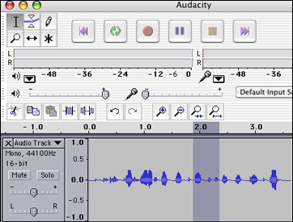
Don’t be afraid to play around with Audacity to learn about more exciting features. You can use a number of tools to alter the sounds you record, creating a number of interesting effects. For most users, however, editing is fun, but not necessary.
Next: Sharing sound.

STEP THREE: SHARE SOUND
Clicking File>Save will allow you to save your project so you can return and edit it later. Audacity does save files in its own format (.aup), however. That means only users with Audacity on their computers can open and listen to your recordings. Not much good for students and parents, right? Hang on…help is at hand.
A second program called Lame converts Audacity files to .mp3 format. That’s the file format recognized by most audio players, including Windows Media Player and iTunes. Mp3 files can be played on almost any computer, as well as on personal mp3 players, such as iPod or Zune.
To install Lame dll, simply follow the instructions here. Note that it’s important to know where on your computer Lame is installed. Most of the time, an icon
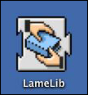
will appear on the Desktop, but it doesn’t really matter where Lame is installed -- as long as you remember where it is. You’ll find out why as you follow the upcoming instructions.
Next: Converting sound files.

CONVERT TO MP3 FILES
To convert Audacity recording to a mp3 file
- Open Audacity.
- Open the file you want to convert.
- Click File>Convert to mp3.
- Click OK (when a window/pane pops up and asks if you want to find Lame).
- Browse to Desktop or My Documents; click LameLib; and click OK.
- When a new window/pane pops up and asks for details about your recording, fill in a title (what the recording was) and artist (who recorded it), and then click OK.
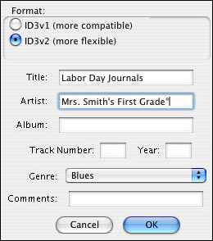
It will take a few minutes to convert your file. Then, you’re done!
To share the file,
- Attach the mp3 file to an e-mail and e-mail it to parents or students.
- Post the mp3 file on the school or class web site.
- Burn the mp3 file onto a CD.
When a student or parent gets to your file (either by saving an e-mail attachment or seeing the file online), they can double-click it and Windows Media Player or iTunes will play the file. Simple!
That’s it…you’ve recorded, edited, and shared sound in three easy steps!
Next: Learn more!

LEARN MORE
Where can I find more information?
Remember, a podcast is just a set of sound recordings, so to get some excellent classroom examples and ideas for sound, check out the podcasting articles below.
- Podcasting Sites to See
- What is a Podcast
- iPod Resource Sites to See
- Creating a Podcast

